SQL Assignment 2

CREATE DATABASE foodie_app;

CREATE TABLE restaurants(
id INT AUTO_INCREMENT,
name VARCHAR(100) NOT NULL,
cuisine VARCHAR(50) NOT NULL,
rating DECIMAL(2,1),
location VARCHAR(100) NOT NULL,
PRIMARY KEY(id)
)

CREATE TABLE users(
user_id INT,
username VARCHAR(30) NOT NULL UNIQUE,
email VARCHAR(40) NOT NULL UNIQUE,
phone_number INT(15)
created_at created_at DATETIME DEFAULT CURRENT_TIMESTAMP,
PRIMARY KEY(user_id)
)

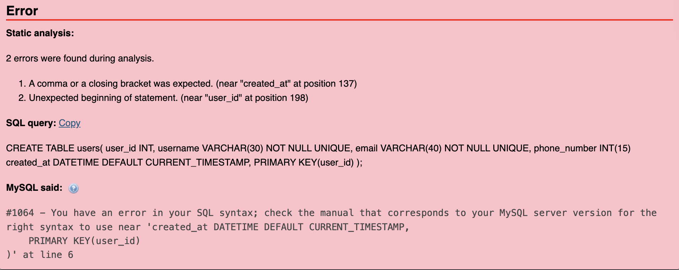

Corrected query:
CREATE TABLE users(
user_id INT,
username VARCHAR(30) NOT NULL UNIQUE,
email VARCHAR(40) NOT NULL UNIQUE,
phone_number INT(15),
created_at created_at DATETIME DEFAULT CURRENT_TIMESTAMP,
PRIMARY KEY(user_id)
)

